**Name : Heri Setiyawan**

**Nim : 11121001**

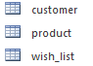**Tables**

**Structure**

**Table Customer**

|  |  |  |  |
| --- | --- | --- | --- |
| **Name field** | **Data type** | **general** | **lookup** |
| Username | text | 50 |  |
| Email | Text | 125 |  |
| No_tlp | Text | 25 |  |

**Table Product**

|  |  |  |  |
| --- | --- | --- | --- |
| **Name field** | **Data type** | **general** | **lookup** |
| Sku | text | 11 |  |
| Model | Text | 50 |  |
| Product_name | Text | 200 |  |
| Price | currency | currency |  |
| stock | number | integer |  |

**Table wish_list**

|  |  |  |  |
| --- | --- | --- | --- |
| **Name field** | **Data type** | **general** | **lookup** |
| Username | text | 50 | Table customer |
| sku | Text | 11 | Table product |

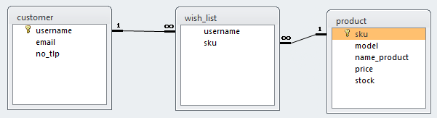**Table Relation**

**Query**

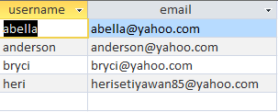**result**

**Query join**

**Result**

